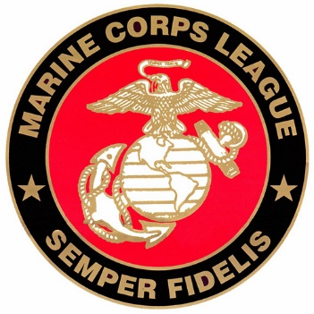

To:

From:

Date: 9 November 2024

Subject: United States Marine Corps 249th Birthday

Dear

Our Athens Georgia, Detachment of the Marine Corps League #1083 is celebrating the long, distinguished, and illustrious history of the United States Marine Corps. On Saturday 09 November 2024, we are hosting the 249th Birthday Celebration for the “Finest Fighting Force” in the World.

Our Detachment is respectfully requesting Friends, Patriots and fans of Marines to be a $200.00 table sponsor. This will allow us to seat eight Marine Corps Veterans and afford them the opportunity to come and participate in the birthday celebration of their beloved Corps. Please make check payable to MCL #1083.

Thank you for your consideration in this matter.

Semper-Fidelis,